Alberta Legislature WebQuest
Name: _________________________
Date: __________________________

Provincial Government Participation
- Identify the steps for the provincial election process and provide an explanation:

Step 1:

Step 2:

Step 3:

Step 4:

Step 5:

Step 6:

- How do candidates make themselves known in their communities so that people will vote for them?
________________________________________________________________________________________________________________________________________________________________________________________________________________________________________________________________________________________________________________________________________________________________________

- Provide 3 differences between Local and Provincial governments:

Provincial Government | Local Government
How does a bill become Law?
Laws in Alberta are voted on by MLAs. When a law is first proposed, it is called a Bill and is introduced into the Legislature for debate. There are several steps involved before a bill finally becomes a law. Before a government bill is introduced, the government caucus discusses the idea. MLAs then talk with interested citizens and groups to find out how they would feel about such a bill.

- Fill in the FIVE steps below:
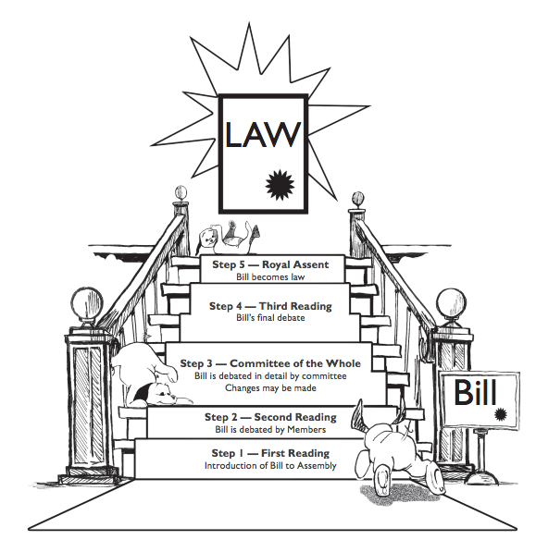
Step 2:
Step 4:
Step 5:
Step 3:
Step 1:

Connecting Symbols and Traditions
If you look around your school, you can probably spot a few symbols. For example, there may be a Canadian flag hanging in your classroom or a picture of the school mascot painted on the gym wall. Sometimes you will have traditions that go along with the symbols, like singing the Canadian anthem at the beginning of a school day.

- Provide an explanation and an example for why certain symbols are displayed in your school:
________________________________________________________________________________________________________________________________________________________________________________________________________________________________________________________________________________________________________________________________________________________________________

- Identify two symbols in the Alberta Legislature and explain their importance:
______________________________________________________________________________________________________________________________________________________________________________________________________________________________________________________________________________________________________________________________________________________________________________________________________________________________________________________________________________________________________________________________________________________________________________________________________________________________________________________

The People of the Assembly: Who Are They, and What do they do?

- Please label the seating plan of the Alberta Legislature

- Explain the role for each of the people listed below:

Title | Role
Lieutenant Governor

Speaker

Members of the Legislative Assembly
MLAs

Government MLAs | Premier:  Cabinet Ministers:  Private Government Members (a.k.a. backbenchers):  The Chair of Committees:
Opposition MLAs | Leader of the Official Opposition:  Members of the Opposition:

Title | Role
Table Officers | Clerk of the Assembly:  Law Clerk:  Parliamentary Counsel:  Committee Research Coordinator:
Sergeant-at-Arms

Pages

Hansard

The Media

- Now that you know what each person does in the Legislative Assembly, which role would you choose? Explain why you would choose that role in the form of a paragraph?
__________________________________________________________________________________________________________________________________________________________________________________________________________________________________________________________________________________________________________________________________________________________________________________________________________________________________________________________________________________________________________________________________________________________________________________________________________________________________________________________________________________________________________________________________________________________________________________________________________________________________________________________________________________________________________________________________________________________________________________________________________________________________________________________________________________________________________________________________________________________________________________________________________________

